***SCNI/01302/2021***

***PASCAL OTIENO***

***COMMUNICATION AND COMPUTER NETWORKS***

***1.Pick an appropriate software engineering methodology (2 marks)***

**Incremental development** is well-suited for this project because it promotes the development of the system in small, manageable increments, allowing for continuous improvement and adaptation based on user feedback. This is particularly beneficial for the Fitness Tracker project as it enables the development team to incorporate new features, such as additional exercise tracking options or nutrition plan adjustments, based on user demands and evolving fitness trends.

***2.Your system uses cases, come up with the following system modelling schemes***

1. Context model

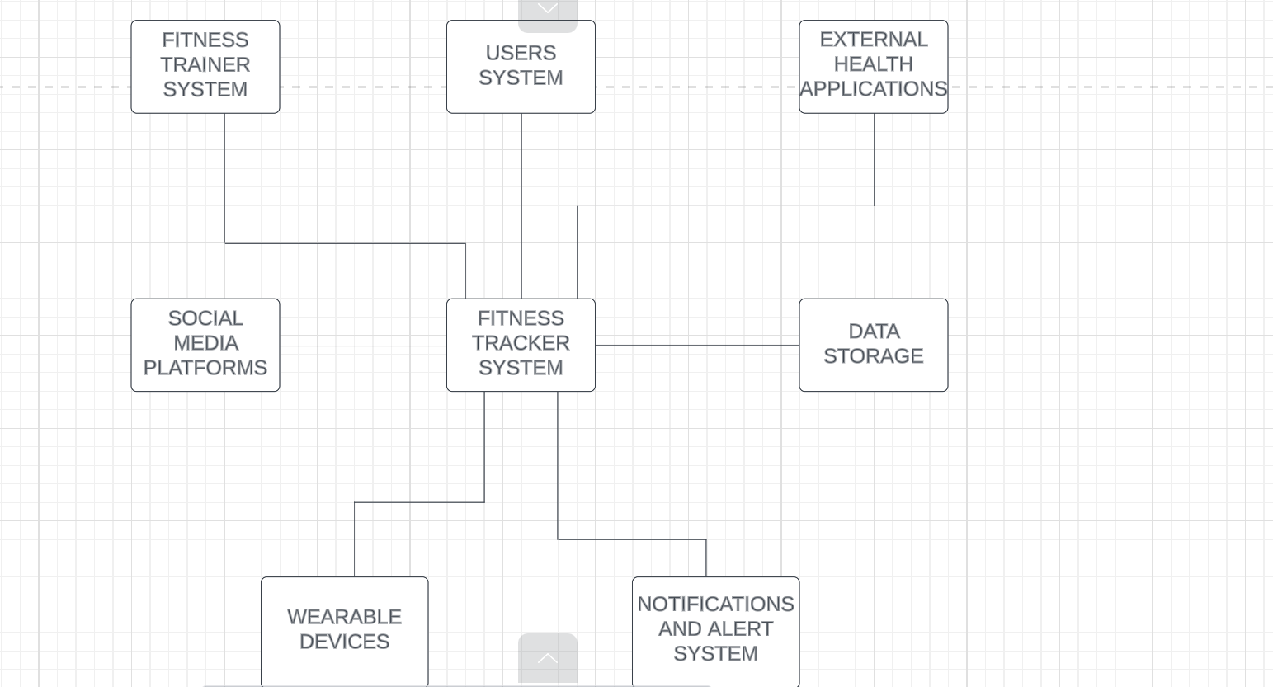

1. Interaction model

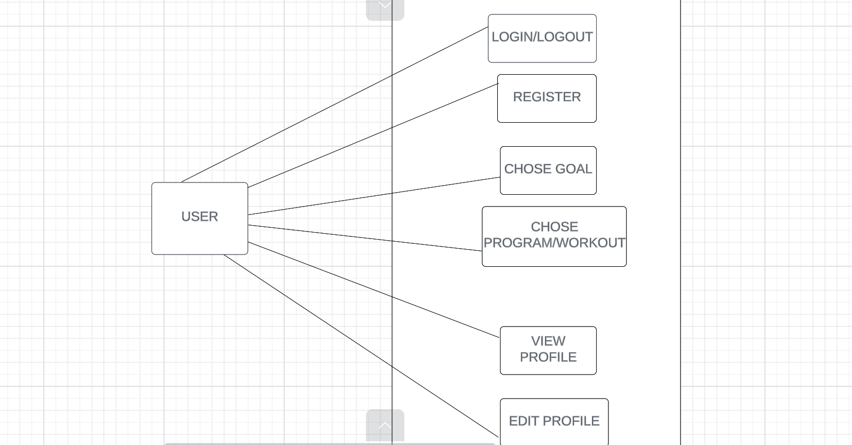

1. Structural model

**In this structural model, the user interacts with the system via the app or the fitness tracker device. The app communicates with the device and stores the transmitted fitness data in the database. The system has a tracking controller that processes and analyzes the fitness data received from the device. The system includes a goal controller to process the user's fitness goals and targets, stores historical fitness data in the History Tracker and displays information to the user through their chosen technology device. The Notification System sends user notifications regarding their progress.**

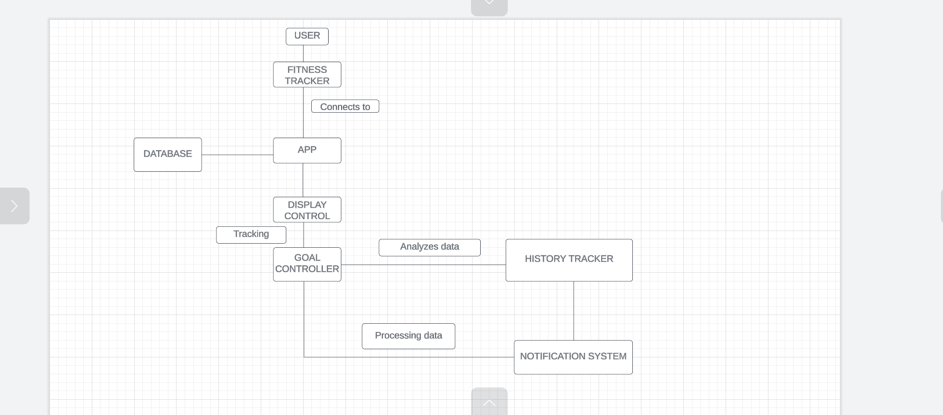

1. Behavioral model

